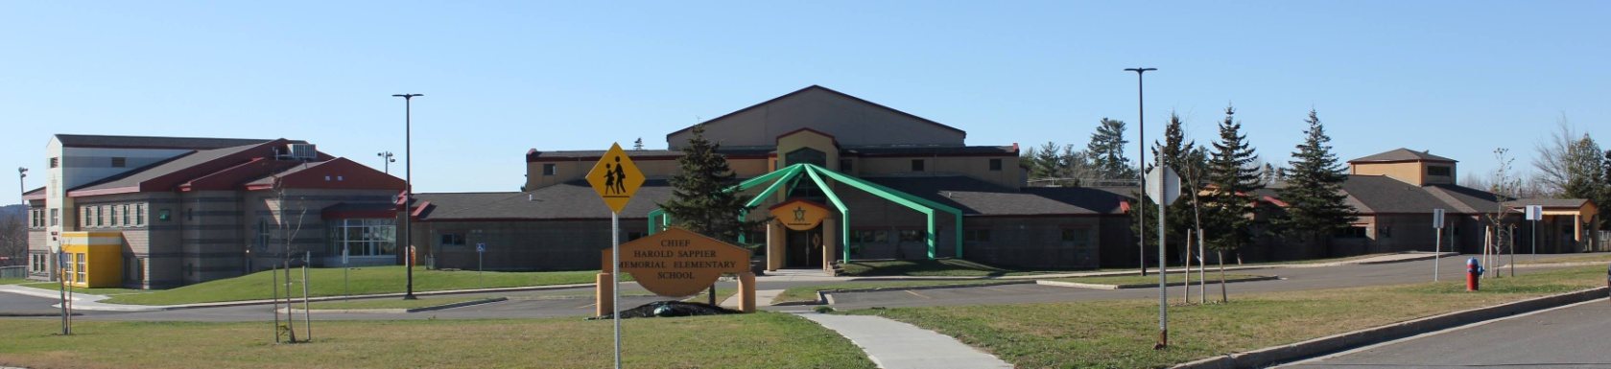
C.H.S.M.E.S. NEWS
April 12th, 2021
462-9683
SEPTEMBER 2008

Parent Teacher

Parent teacher will be Thursday, April 15th in the evening and Friday April 16th until noon.

Teachers will be contacting you to set up your telephone meeting.

*Reminder *
This is different than the ASD-W calendar. There will be school here at CHSMES on Wednesday, however NO school on Friday April 16th.

CHINESE HOT LUNCH

Thursday, April 15th

Chicken Balls & Rice
$4.00

Orders must be in on Wednesday by noon!

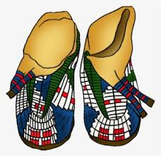
Wolastoq Wednesday
April 14th
Wear your traditional clothing, ribbon shirts/skirt, beaded earrings or mocs.
Or
Rock your school swag

Wednesday, April 14th- Wolastoq Wednesday
Thursday, April 15th- Hot Lunch, parent teacher (PM)
Friday, April 16th- NO SCHOOL, Parent Teacher (AM)

*Afterschool will be open on Friday April 16th *

Enjoy Your Long Weekend

Please Continue to send your rubber boots, splash pants, and extra clothing

