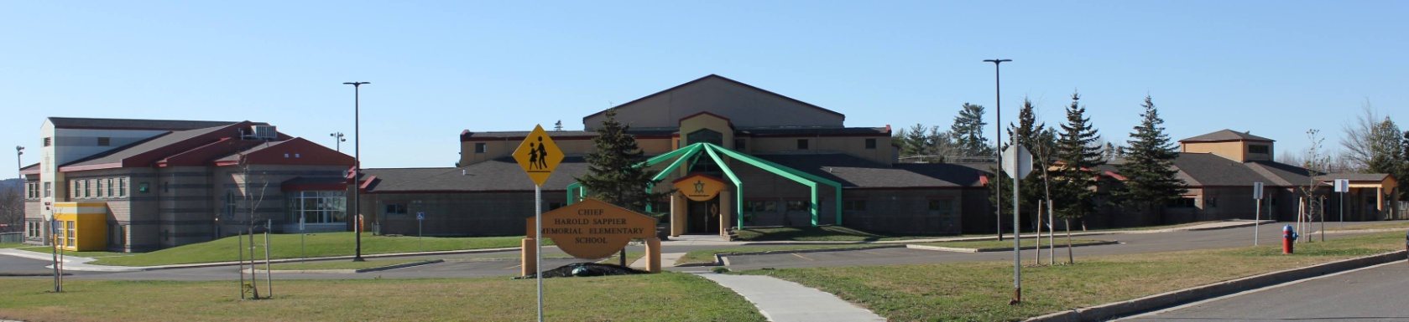
C.H.S.M.E.S. NEWS
April 19th, 2021
462-9683
SEPTEMBER 2008
Jordan’s Principle hours of operation
St.Marys Band office-3rd Floor

Wednesdays & Thursdays
9am-430pm

Dillon Paul-Case Coordinator
Phone: 472-1232
Email: Dillonpaul.mawiw@efned.ca

CHINESE HOT LUNCH

Friday, April 23rd

Chicken Balls & Rice
$4.00

Orders must be in on Thursday by noon!

Wolastoq Wednesday
April 21st
Wear your traditional clothing or your school swag

Wednesday, April 21st- Wolastoq Wednesday
Thursday, April22nd- Earth Day
Friday, April 23rd - Hot Lunch (orders due Thursday)

Enjoy Your Long Weekend

Earth Day
Thursday, April 22nd
The School will be going out at 1pm to clean up our school and do our part in keeping mother earth clean
Ankeyuwan Kikuwosson Skitkomiq- Take care of mother earth

