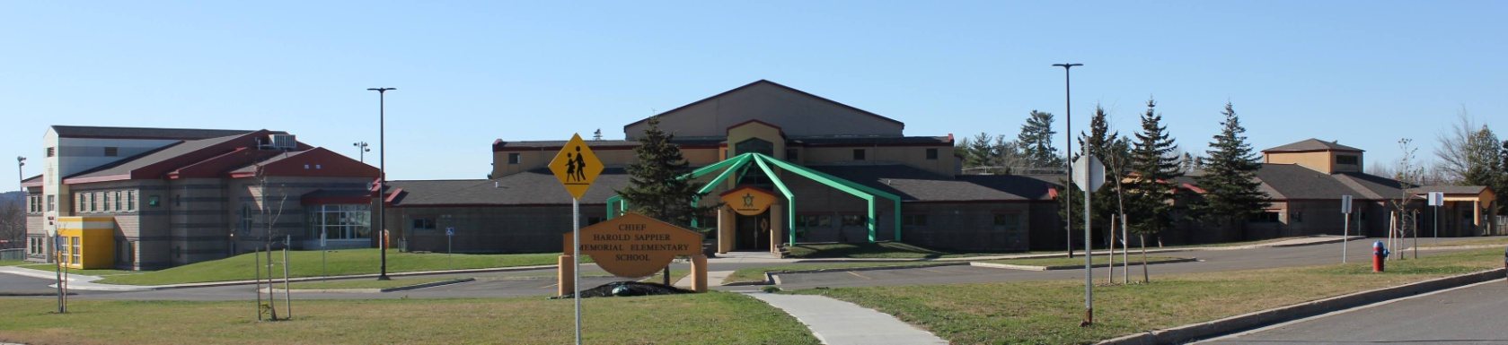
C.H.S.M.E.S. NEWS
April 6th, 2021
462-9683
SEPTEMBER 2008

CHINESE HOT LUNCH

Friday, April 9th

Chicken Balls & Rice
$4.00

Orders must be in on Thursday at noon!

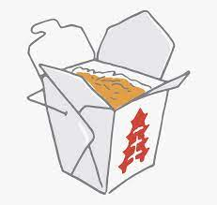

Wolastoq Wednesday

Wear your traditional clothing on Wednesday! Mocs, beaded earrings, ribbon skirts or shirts!

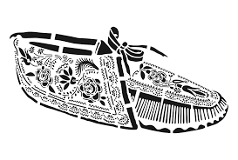

Parent teacher
*Important date is different than ASD-W Calendar*

Parent teacher interviews will be scheduled Thursday evening, April 15th and Friday, April 16th until noon.

There will be No School Friday, April 16th

Virtual Recognition awards, Friday April 9th
(Viewed in class only, not available to parents online, teachers will post results later on)

Please continue to send rubber boots, splash pants and extra clothing in case we get wet and muddy out there

Important Reminders: Spring is here, we need rubber boots, splash pants and extra clothing in case we get wet and muddy out there! Please also continue to send two clean face mask every day!
Enjoy Your Long Weekend

