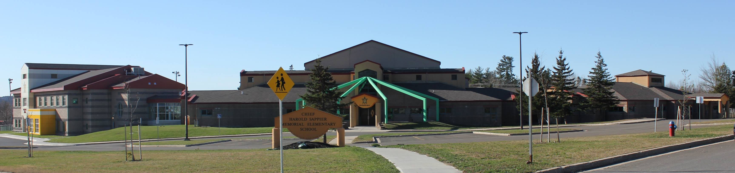
C.H.S.M.E.S. NEWS
December 14th, 2020
462-9683
SEPTEMBER 2008

Merry Christmas
Ktoli-wihkutomulpa kuli-nipayimiyaniya naka kuli-pilikotonomaniya!

Wednesday, December 16th
Reminder, last day of school for CHSMES is Wednesday, December 16th
K3 & K4- Dismissed at 11:00
K5 to Grade 2- Dismissed at 11:30
Grade3 to Grade 6- Dismissed at 12:00

SCHOOL PHOTOS

For those who got retakes, please have your photos in by Tuesday morning, December 15th.

They will be home delivered upon arrival

We are back to school on
Monday, January 4th 2021

See you in the New Year!

