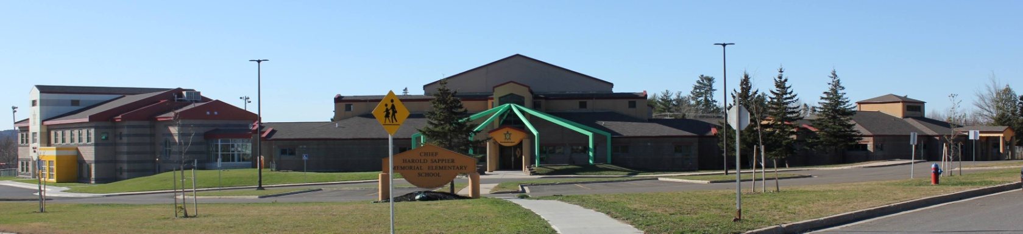

**C.H.S.M.E.S. NEWS**

**December 7th, 2020**

462-9683

**SEPTEMBER 2008**



**Virtual concert recording**

**Tuesday, December 8th**

Our CHSMES Christmas Concert will look a little different this year. On Tuesday we will be recording our Virtual Christmas Concert. We are asking to students to wear their best Christmas Outfit or Traditional Regalia, Moccasins, beaded bling, ribbon shirts, or your hair in braids.

We look forward to sharing our Christmas Spirit!!

**Hot Lunch**

**Friday, December 11th**



**Turkey Dinner donated by the SMEC**

(If your child does not want turkey dinner please send a lunch)

**Pajama Party**



Wear your pajamas on December 14th

December 9th wear your Christmas Sweater!

Winter is coming!

**School Closures due to Storms**

Please listen to the radio for school closures. If **Anglophone West School District** Schools are closed, CHSMES will also be closed. Announcements will be posted on our CHSMES Facebook pages or on the radio.

Should school be closed early on days when it is anticipated that weather conditions may deteriorate significantly, it is important that parents have alternative arrangements for their children if they or another adult will not be home to receive your child. Please ensure that the school has an up-to-date contact number such as work numbers or cell number and at least one emergency contact number.

Should SMFN busses be running late, CHSMES will be open at the regular time. **Afterschool care will open at 9:00 a.m.**

**Other Important dates to remember:**

**Wednesday, December 16th- Last day of school**

**Monday, January 4th- First Day back to classes**

Reminder, we must have two clean face mask each day. With the wet and colder weather coming its important we change them if they become damp.

Thank You 😊

**Reminder that we need two clean mask every day, please remember to wash your hands frequently, keep your hands away from eyes, mouth and nose, if you’re feeling unwell, stay home, self-monitor, Together, we’re doing everything we can to stay safe and keep our friends and family healthy.**



