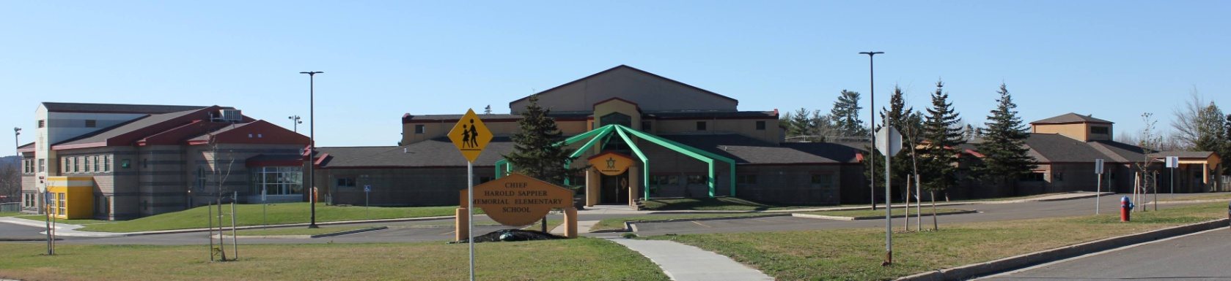
C.H.S.M.E.S. NEWS
February 1st , 2020
462-9683
SEPTEMBER 2008

February Hot lunch will be chicken fingers and potato wedges. The cost will be $4.00.
Orders must be in by Thursday by noon. We cannot accept any late orders.

Wolastaq Wednesday

Wear your traditional clothing on Wednesday! Mocs, beaded earrings, ribbon skirts or shirts!

School Closures due to Storms
Please listen to the radio for school closures. If Anglophone West School District Schools are closed, CHSMES will also be closed. Announcements will be posted on our CHSMES Facebook pages or on the radio.
Should school be closed early on days when it is anticipated that weather conditions may deteriorate significantly, it is important that parents have alternative arrangements for their children if they or another adult will not be home to receive your child. Please ensure that the school has an up-to-date contact number such as work numbers or cell number and at least one emergency contact number.
Should SMFN busses be running late, CHSMES will be open at the regular time.
After school will have a delayed opening of 9AM on storm days, however, please watch for updates on the website in case road conditions worsen and we have to close afterschool as well.

FEBRUARY 3RD – WOLASTAQ WEDNESDAY
FEBRUARY 5TH- PJ DAY & HOT LUNCH
FEBUARY 15TH – FAMILY DAY-NO SCHOOL

Upcoming dates to remember

Important Reminders: Please send snow pants, extra hats and mitts as we go outside two times a day weather permitting and please send two clean face mask each day!

Woliwon for doing your part in keeping CHSMES a healthy and safe environment!

