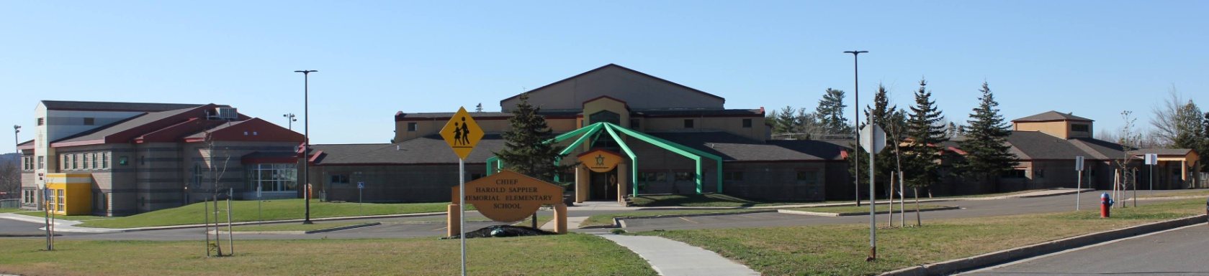
C.H.S.M.E.S. NEWS
February 17th 2021
462-9683
SEPTEMBER 2008

Wolastaq Wednesday

Wear your traditional clothing on Wednesday! Mocs, beaded earrings, ribbon skirts or shirts!

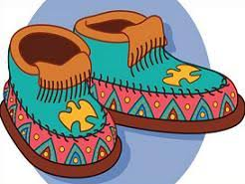

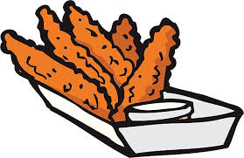

Reminder: Hot Lunch on Fridays

For the month of February, hot lunch will be chicken fingers and tators. Orders must be in by Thursday at noon. The cost is $4.00.

FYI…Hot Lunch IF there is a snow day – in the event that we have a snow day on any Friday of hot lunch, we will move it ahead to the following Friday after the last scheduled date.

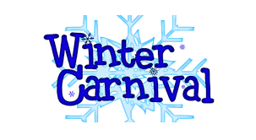
WINTER CARNIVAL WEEK
FEBRUARY 22ND-26TH
Please make sure to send snow pants, warm jackets, extra hats and mitts all week

Schedule
Monday- Dress-Up (Favorite Character)
Tuesday- Crazy Hair/Hat Day
Wednesday- Pink Shirt/Wolastaq Wednesday
Thursday- Jersey Day
Friday- PJ Day

FEBRUARY 19TH- HOT LUNCH & PJS
FEBUARY 24TH – PINK SHIRT DAY
MARCH 1-5TH – MARCH BREAK
MARCH 19TH – PD DAY

Upcoming dates to remember

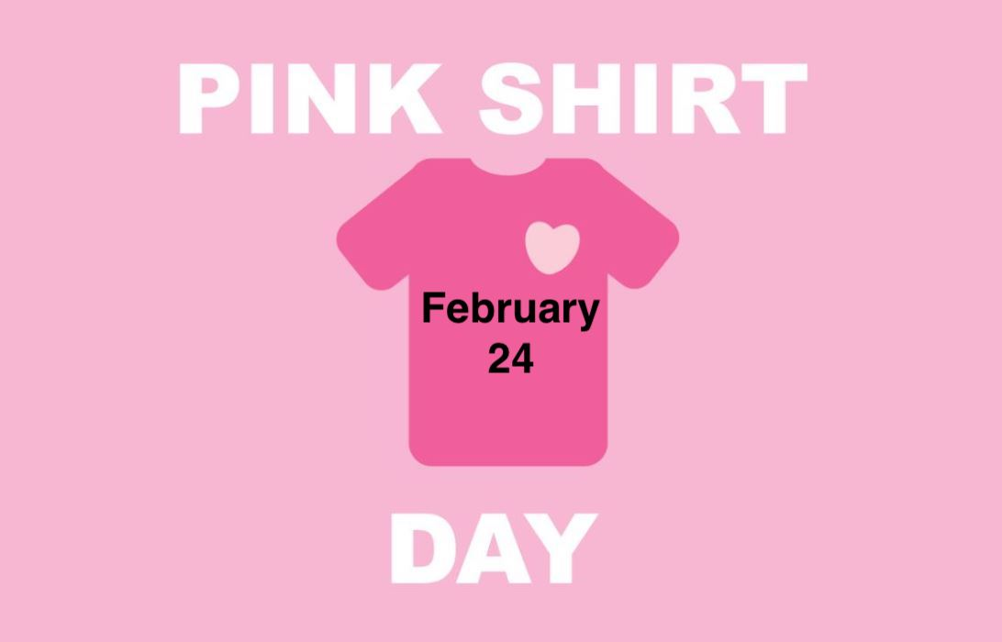

Wednesday, February 24th

Important Reminders: Please send snow pants, extra hats and mitts as we go outside two times a day weather permitting and please send two clean face mask each day!

Woliwon for doing your part in keeping CHSMES a healthy and safe environment!

