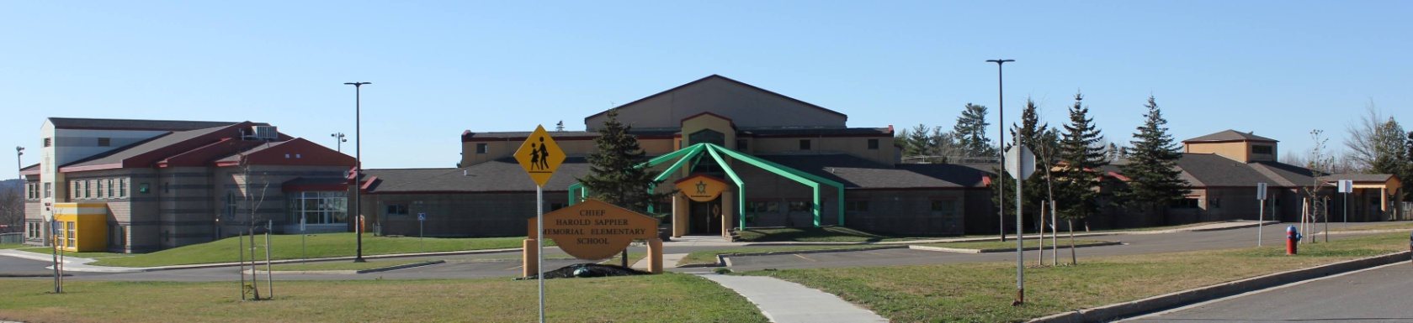
C.H.S.M.E.S. NEWS
February 8th , 2020
462-9683
SEPTEMBER 2008

HAPPY TEACHER APPRECIATION WEEK!

Wolastaq Wednesday

Wear your traditional clothing on Wednesday! Mocs, beaded earrings, ribbon skirts or shirts!

Reminder: Hot Lunch on Fridays

For the month of February, hot lunch will be chicken fingers and tators. Orders must be in by Thursday at noon. The cost is $4.00.

FYI…Hot Lunch IF there is a snow day – in the event that we have a snow day on any Friday of hot lunch, we will move it ahead to the following Friday after the last scheduled date.

Valentines at CHSMES February 12th

Valentine Cards and Treats – Valentine’s Day will soon be upon us and with it brings sweet cards and sweets! Please note that students can share cards within their bubble as well as prepacked treats.

FEBRUARY 10TH – WOLASTAQ WEDNESDAY
FEBRUARY 12TH- HOT LUNCH, PJS &
VALENTINES PARTY
FEBUARY 15TH – FAMILY DAY-NO SCHOOL
FEBUARY 24TH – PINK SHIRT DAY

Upcoming dates to remember

CHSMES will be providing a pink shirt to every child

Important Reminders: Please send snow pants, extra hats and mitts as we go outside two times a day weather permitting and please send two clean face mask each day!

Woliwon for doing your part in keeping CHSMES a healthy and safe environment!

