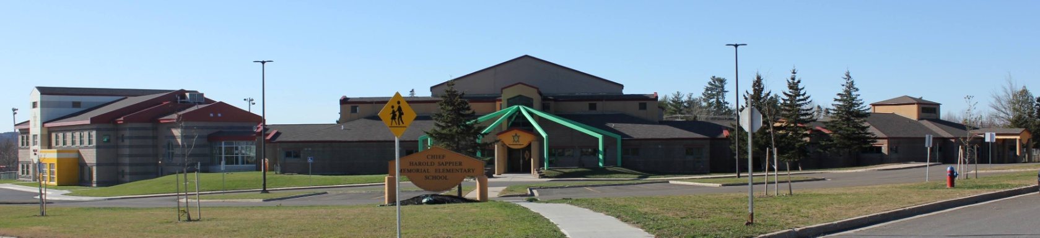
C.H.S.M.E.S. NEWS
January 4th, 2021
462-9683
SEPTEMBER 2008

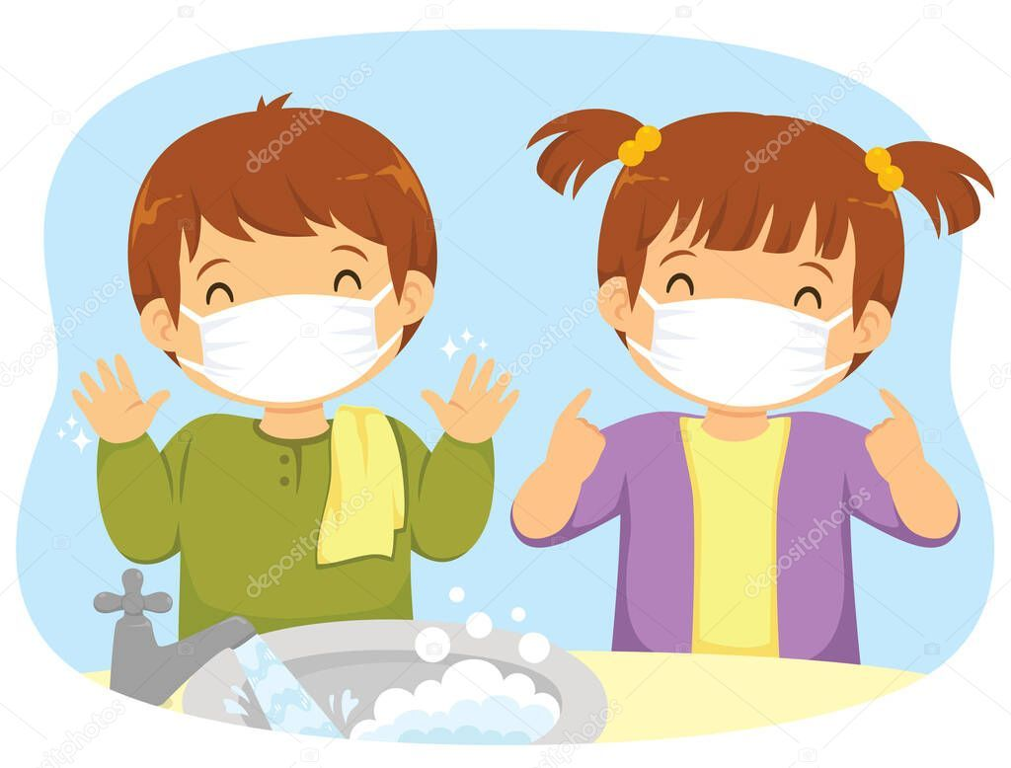

Reminder, we must have two clean face mask each day. With the wet and colder weather here, it is important we change them

Hot Lunch on Fridays

We will be serving pizza on Fridays starting on Friday January 8th!

Pizza will be $1 a slice

Please have money and form with how many slices your child is ordering by Thursday mornings.

Winter is here!
School Closures due to Storms

Please listen to the radio for school closures. If Anglophone West School District Schools are closed, CHSMES will also be closed. Announcements will be posted on our CHSMES facebook pages or on the radio.
Should school be closed early on days when it is anticipated that weather conditions may deteriorate significantly, It is important that parents have alternative arrangements for their children if they or another adult will not be home to receive your child. Please ensure that the school has an up-to-date contact number such as work numbers or cell number and at least one emergency contact number.
Should SMFN busses be running late, CHSMES will be open at the regular time

“Mask up” Campaign

An important announcement CHSMES will be following the “mask up” campaign for the first two weeks returning from break starting today January 4th.

Students and staff will be asked to wear a mask throughout the day as an extra layer of protection. Although this is not idea, we can all do our part to keep CHSMES healthy and safe. Please see below for more information.
