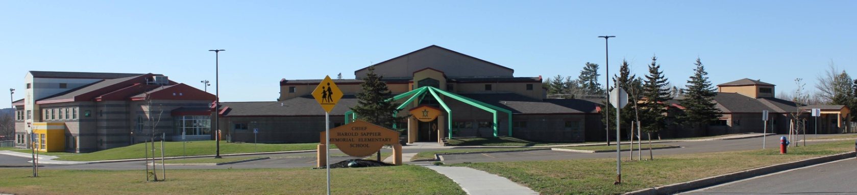

**C.H.S.M.E.S. NEWS**

**January 11th, 2021**

462-9683

**SEPTEMBER 2008**

Important Reminder

We continue to go outside at recess and lunch, weather permitting, so please remember to send winter gear to school, snow pants, winter jackets, warm socks, boots and extra mitts and hats.

**School Closures due to Storms**

Please listen to the radio for school closures. If **Anglophone West School District** Schools are closed, CHSMES will also be closed. Announcements will be posted on our CHSMES Facebook pages or on the radio.

Should school be closed early on days when it is anticipated that weather conditions may deteriorate significantly, it is important that parents have alternative arrangements for their children if they or another adult will not be home to receive your child. Please ensure that the school has an up-to-date contact number such as work numbers or cell number and at least one emergency contact number.

Should SMFN busses be running late, CHSMES will be open at the regular time.

**Reminder you need two clean facemask each day!**

**Remember if you have one or more symptom or are not feeling well- Stay Home!**

**Woliwon for your continued effort to keep CHSMES a safe and healthy environment.**

**Pizza Friday on January 15th**

**$1 a slice**

**Have money and order in no later than Thursday at noon.**