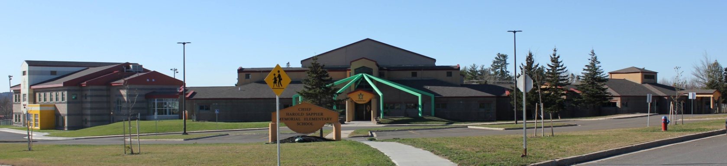

**C.H.S.M.E.S. NEWS**

**January 18th, 2021**

462-9683

**SEPTEMBER 2008**

**Reminder Pizza Friday**

**January 22nd**

**$1.00 a slice**

**Please have order and money in no later than Thursday at noon**

Wolastaq Wednesdays

Wear your tradional clothing on Wednesdays! Mocs, beaded earrings, ribbon skirts or shirts!

**\*Important update\***

CHSMES students and staff have done a great job following the Covid-19 guidelines suggested by province. We have also added additional safety measures to ensure a healthy and safe environment for all students and staff. Our custodians and staff have worked tirelessly to keep CHSMES clean and safe.

We ask for parents to continue to be diligent and if students have any symptoms, we ask that they stay home until symptoms are gone and contact SMFN Health center or 811 for further guidance.

If students are symptom free, we ask that you continue to send your students here to CHSMES as directed by Public Health. Please continue to send at least 2 clean masks with your child daily and keep washing those hands! We will get through this together!

If you have any questions or concerns, please call the school at 462-9683.

Woliwon naka Wolamsotas!

Winter is here!

**School Closures due to Storms**

Please listen to the radio for school closures. If **Anglophone West School District** Schools are closed, CHSMES will also be closed. Announcements will be posted on our CHSMES Facebook pages or on the radio.

Should school be closed early on days when it is anticipated that weather conditions may deteriorate significantly, it is important that parents have alternative arrangements for their children if they or another adult will not be home to receive your child. Please ensure that the school has an up-to-date contact number such as work numbers or cell number and at least one emergency contact number.

Should SMFN busses be running late, CHSMES will be open at the regular time.