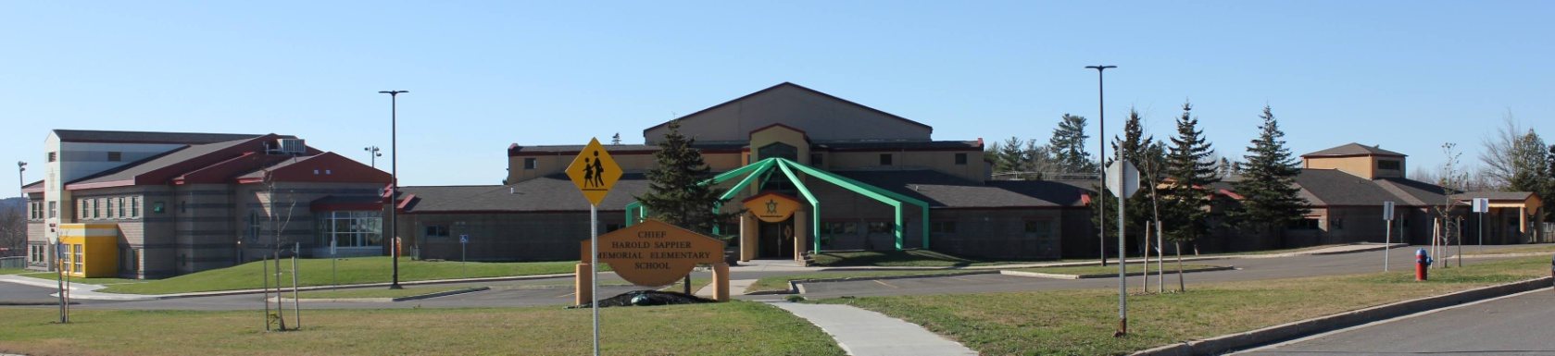
C.H.S.M.E.S. NEWS
January 25th, 2020
462-9683
SEPTEMBER 2008

Reminder: Hot Lunch on Fridays

Last week for Pizza Friday $1 a slice is this Friday, January 29th. Please have orders in on Thursday by noon.

Wolastaq Wednesday

Wear your traditional clothing on Wednesday! Mocs, beaded earrings, ribbon skirts or shirts!

JANUARY 27TH – WOLASTAQ WEDNESDAY
JANUARY 29TH- PIZZA DAY & PJS
FEBUARY 15TH – FAMILY DAY-NO SCHOOL

FRIDAY JANUARY 29TH

Virtual Recognition
Awards
January 29th at 1pm

Upcoming dates to remember

Important Reminders: Please send snow pants, extra hats and mitts as we go outside two times a day weather permitting and please send two clean face mask each day!

Woliwon for doing your part in keeping CHSMES a healthy and safe environment!

