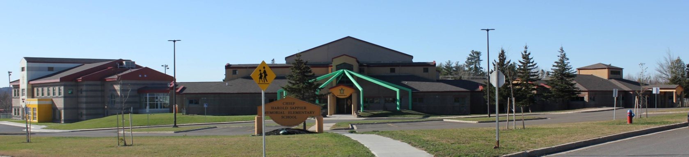

**C.H.S.M.E.S. NEWS**

**June 14th, 2021**

462-9683

**SEPTEMBER 2008**

Year End Party

Friday, June 18th

All Day of fun for all grades. Bouncy castles, dunk tank, gigantic slip n slide and games, all day long!

Subway Lunch donated by health center ☺

***Please send swimsuit and towel***

This event is for CHSMES students only, we cannot allow parents due to covid restrictions, thank you for your understanding.

National Indigenous Peoples Day

Monday, June 21st

No school

2 Weeks

of School until

Summer Break!

**Reminder: Summer All day Program deadline is June 17th, if you have not received the application, please call the office or stop by and pick one up.**

**Tuesday, June 15th is our year end virtual celebration recording.**

We are asking all students to dress up, wear your traditional clothing or your best outfit ☺

Important Dates

Thursday, June 23rd- Summer Package tickets due

Friday, June 18th- End of Year Party!

**Friday, June 18th-** **Last day for early years progra**m!

Monday, June 21st- No School- Indigenous Day!

Thursday, June 24th- Last Day for students