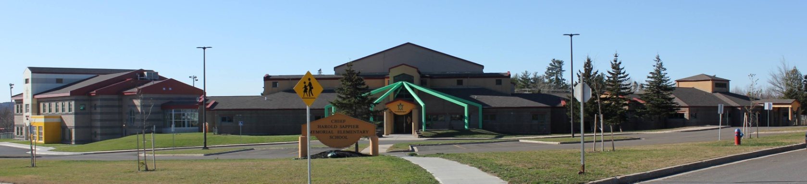

**C.H.S.M.E.S. NEWS**

**March 15th, 2021**

462-9683

**SEPTEMBER 2008**

Reminder: Please continue to send two clean masks, and warm winter clothing with your children every day.

Wear Green on Wednesday for St. Patrick’s Day

Or wear your Traditional clothing for Wolastaq Wednesday!

**Hot Lunch**

**Goulash and garlic bread for $4.00**

**Thursday March 18th**

**Money must be in by Wednesday at noon**



Friday, March 19th- PD DAY

No School



**March 17th-St Patrick’s Day-Wear Green**

**March 18th- Hot Lunch**

**March 19th- PD Day (Afterschool program will be open)**

**March 26th- Hot Lunch**