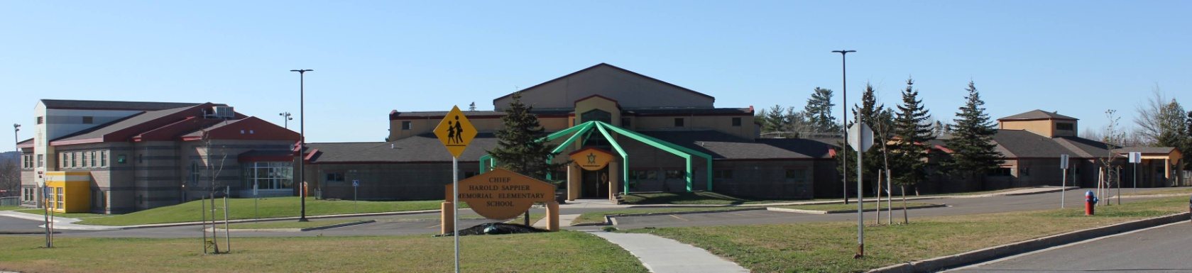
C.H.S.M.E.S. NEWS
March 29th2021
462-9683
SEPTEMBER 2008

Thursday April 1st

Chicken Balls & Rice
$4.00

Orders must be in on Wednesday by noon
No late orders can be accepted

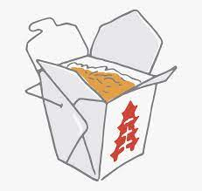

Wolastoq Wednesday

Wear your traditional clothing on Wednesday! Mocs, beaded earrings, ribbon skirts or shirts!

Virtual Recognition
Awards
April 1st at 1pm
(Awards are viewed in class only, not available to parents online, teachers will post results of the awards later on)

No School Good Friday & Easter Monday
(Afterschool also closed)

Woli Apicipe

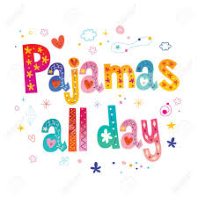
Thursday, April 1st

Important Reminders: Spring is here, we need rubber boots, splash pants and extra clothing in case we get wet and muddy out there! Please also continue to send two clean face mask every day!
Enjoy Your Long Weekend

