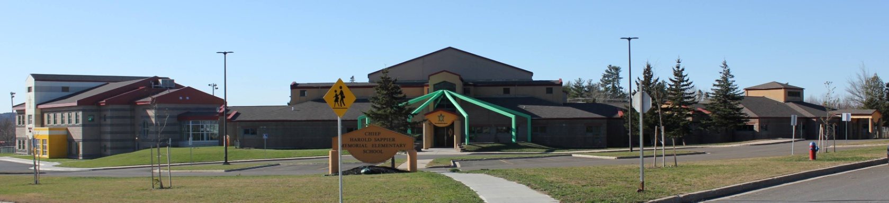

**C.H.S.M.E.S. NEWS**

**March 8, 2021**

462-9683

**SEPTEMBER 2008**

**Jordan’s Principle**

Dillion Paul, coordinator from Jordan’s Principle will be here on Wednesday at the school in the afternoon from 1-4:30 if anyone has any questions or would like to see him in regards to your funding. Please call him if you would like to set up an appointment at 472-1232

Welcome back students from March break.

I hope everyone enjoyed their March break and are rested up and excited to get back to school. As we head back to school tomorrow and with the return to the “yellow phase”, students will not be required to wear masks in their classroom bubble! Students will also not have to wear mask outside on the playground during recess. This is such welcomed news as we return to school!

We will still be encouraging that students continue to wear mask on the bus, entering/exiting the building, and in common areas such as hallways in the school where physical distancing cannot be maintained. Thank you for your continued support!

Woliwon naka Wolamsotas!

**Hot Lunch**

**Every Friday in March**

**Goulash and garlic bread for $4.00**

**Please note because of the PD day on March 29th, hot lunch will be served on Thursday, March 18th.**

Wolastaq Wednesdays

Wear your traditional clothing on Wednesday! Mocs, beaded earrings, ribbon skirts or shirts!





**March 12th- Hot Lunch**

**March 18th- Hot Lunch**

**March 19th- PD Day (Afterschool program will be open)**

**March 26th- Hot Lunch**