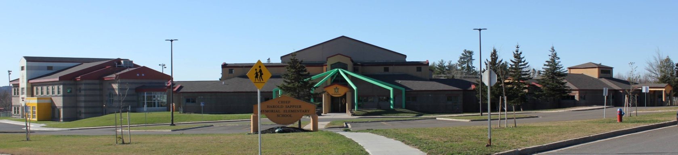

**C.H.S.M.E.S. NEWS**

**May 18th, 2021**

462-9683

**SEPTEMBER 2008**

HOT LUNCH

**Hot lunch for the month of May will be a BBQ every week!**

**Hot Dog & Juice Box $2**

**Burger & Juice Box- $3**

Monday, May 24th

Victoria Day- NO SCHOOL

**Afterschool is also closed!**

Wednesday, May 19th

Wolastaq Wednesday

Wear your Mocs, ribbon skirts/ribbon shirts and beaded earrings, or wear your CHSMES school swag!

6 weeks of School until summer break!

**Important Dates**

**Wednesday, May 19th- Wolastaq Wednesday**

**Friday, May 21st – Hot Lunch**

**Monday, May 24th- No School- Victoria Day**

Pihtahkisluhkemk iyu!