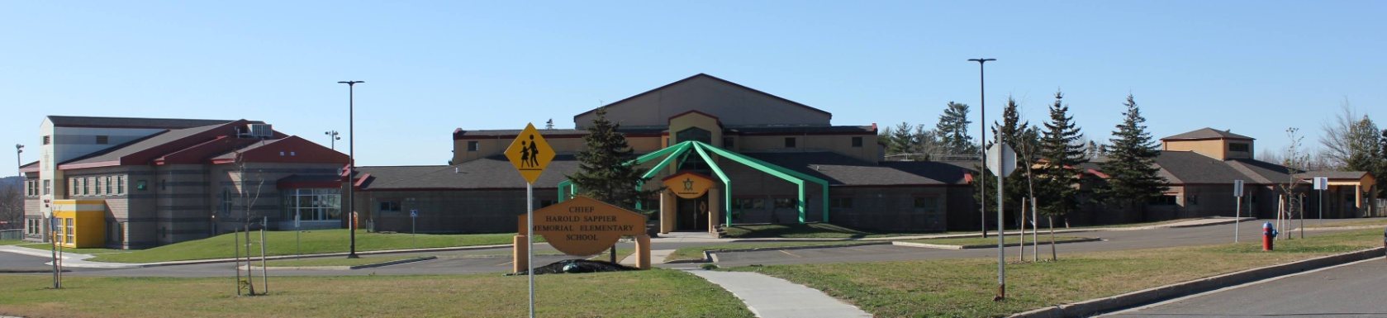

**C.H.S.M.E.S. NEWS**

**May 31st 2021**

462-9683

**SEPTEMBER 2008**

Wolastoq Wednesday

Wear your traditional clothing on Wednesday! Mocs, beaded earrings, ribbon skirts or shirts!

**Friday, June 4th**

**Track & Field**

**Leo Hayes Track**

**Reminder: Send water bottles & Running shoes, please apply sunscreen before ☺**

**Lunch will be provided on Friday for all classes**

Year End Party

Outdoor Fun Day!

More details to come ☺

4 Weeks

of School until

Summer Break!

Important Dates

Wednesday, June 2nd- Wolastoq Wednesday

Friday, June 4th- Track & Field and Pizza Party

Friday, June 18th- Year End Party

Monday, June 21st- Indigenous Day- School Closed

Thursday, June 24th- Last Day for students