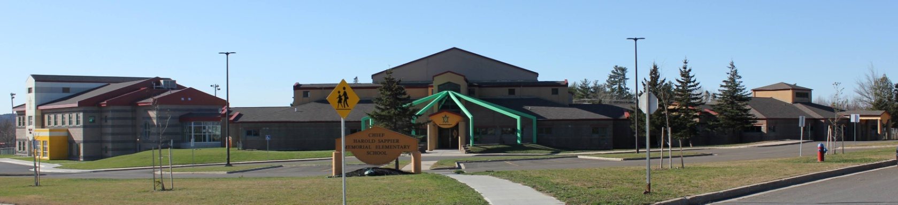

**C.H.S.M.E.S. NEWS**

**November 17th, 2020**

462-9683

**SEPTEMBER 2008**



**WALKING TACOS**

**Thursday, November 19th**

**$4.00**

All orders must be in on Wednesday morning!

Please bring the exact amount of change, our numbers are increasing for our lunch orders and unfortunately

we cannot keep track who to credit.



Picture Retakes

Thursday, November 19th

Winter is coming!

**School Closures due to Storms**

Please listen to the radio for school closures. If **Anglophone West School District** Schools are closed, CHSMES will also be closed. Announcements will be posted on our CHSMES facebook pages or on the radio.

Should school be closed early on days when it is anticipated that weather conditions may deteriorate significantly, it is important that parents have alternative arrangements for their children if they or another adult will not be home to receive your child. Please ensure that the school has an up-to-date contact number such as work numbers or cell number and at least one emergency contact number.

Should SMFN busses be running late, CHSMES will be open at the regular time.





**NOVEMBER 20th** – PD DAY

(Afterschool program will be open)

A reminder from our school Nurse: Just a friendly reminder that flu season is upon us, it is important to minimize the flu by remembering to wash our hands frequently, drinks lots of water, keep hands away from eyes, mouth and nose, stay active and get your flu shot if you are able ☺

Important reminder: You need two clean mask and your own water bottle!