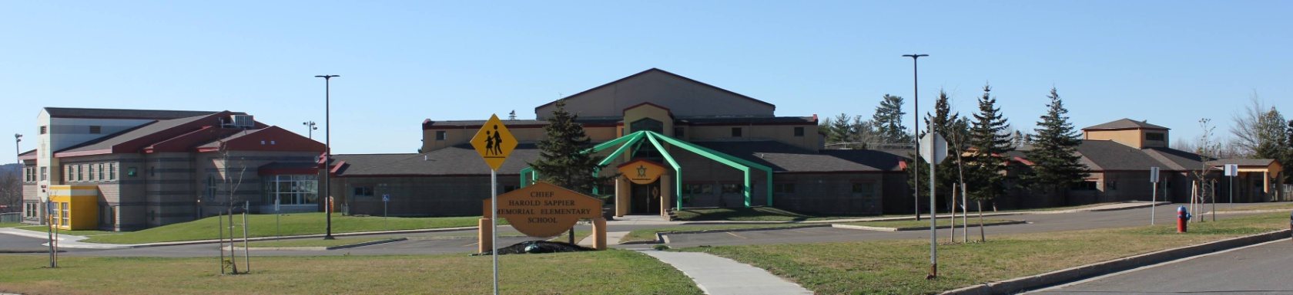

**C.H.S.M.E.S. NEWS**

**November 2nd, 2020**

462-9683

**SEPTEMBER 2008**



**Reminder: Hot Lunch on Fridays**

All orders must be in on Thursday mornings. If there is no school on Friday that means hot lunch is on Thursday and orders will have to be in on Wednesday mornings.

Please bring the exact amount of change, our numbers are increasing for our lunch orders and unfortunately

we cannot keep track who to credit.

Friday November 6th- Chicken Fingers & Fries with a juice box.





Pictures are due back November 9th

Picture Retakes

November 19th

**COOLER WEATHER**

We are now getting into the cooler weather. We continue to go outside weather permitting for recess and lunch. Please ensure your child is dressed for the weather.

Terry Fox Fundraiser

We raised $191.00





**NOVEMBER 11th** – REMEMBRANCE DAY

**NOVEMBER 16th-** SMFN ELECTION DAY

**NOVEMBER 20th** – PD DAY

A Message from our School Nurse: Third year UNB Nursing students visited classrooms at CHSMES on October 16th and 23rd to discuss important health promotion topics with your students.  For the first session we covered handwashing and included a really fun activity so the children could better understand the importance of washing our hands regularly as well as the proper steps to take when performing hand hygiene. We highlighted the ways in which germs can spread, where germs live, and how important it is for us to keep ourselves, our friends, our families, and others around us, healthy!  On the 23rd we discussed the importance of wearing our masks during this time, how masks work; we wore personal protective equipment (PPE) into the classrooms to demonstrate how the equipment works and what it means when they see others wearing it so they are familiar with it and not scared. We will return in the weeks to come and will continue to provide education on other important health related topics.