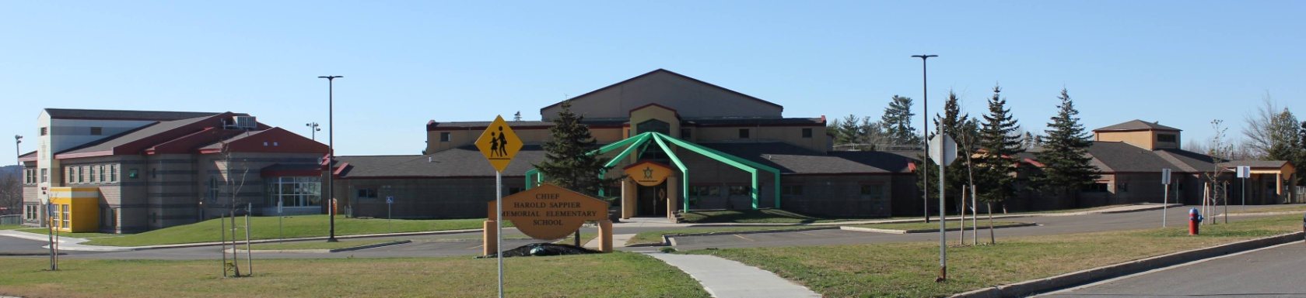

**C.H.S.M.E.S. NEWS**

**November 9th, 2020**

462-9683

**SEPTEMBER 2008**

Remembrance Day November 11th 2020- No School

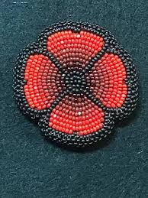

Unfortunately, this year, due to COVID 19, we are unable to have our traditional Remembrance Day Ceremony assembly for students, staff, and our community here at CHSMES, our staff and students will be taking time to observe Remembrance Day in the classroom on November 10th.

Hot Lunch Friday Nov 13th



Lasagna served with garlic bread and Caesar salad $4.00

Money must be in by Thursday morning, please have exact change!

The UNB Nursing Students were back at CHSMES on Nov.6th to discuss healthy eating in each class. Your children were very engaged and made great contributions to our discussions! In the older class we played a game to learn about carbs, fats and proteins; the younger grades helped us pack our lunch boxes with healthy food choices. In some classes we had time to discuss physical activity and had fun getting our heart rates up to help your children understand the importance of exercising our heart and muscles.

We know with election day coming up you will have a day at home so here are some ideas you can enjoy together as a family and limit your screen time:

1. Play hide and seek
2. Have a dance party
3. Try a new recipe
4. Play board games
5. Go camping in the living room or outside
6. Create a scavenger hunt or treasure hunt outdoors
7. Build a fort indoors or outdoors
8. Make a time capsule
9. Go for a walk
10. Go to the library
11. Have a picnic
12. Go for a bike ride
13. Play cards
14. Learn to knit or crochet
15. Do beading

**Reminders:**

We are closed on Monday, November 16th for SMFN Election day

Picture Retakes are on November 19th

PD Day on November 20th- No School

Mask are required for the bus. Please ensure your child has his/her mask with them in the mornings



**COOLER WEATHER**

We are now getting into the cooler weather. We continue to go outside weather permitting for recess and lunch. Please ensure your child is dressed for the weather.

