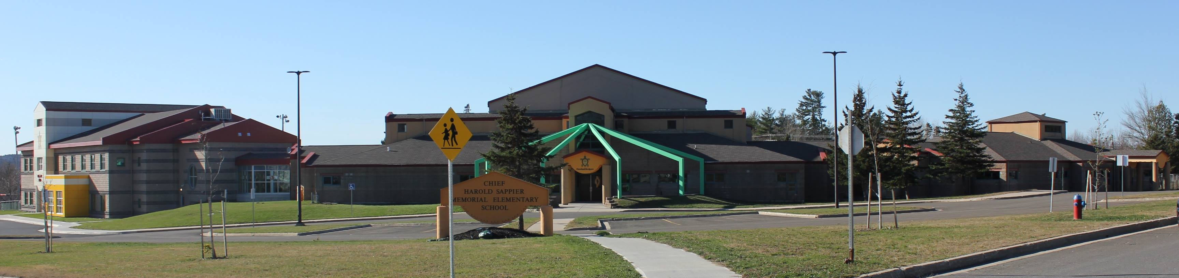

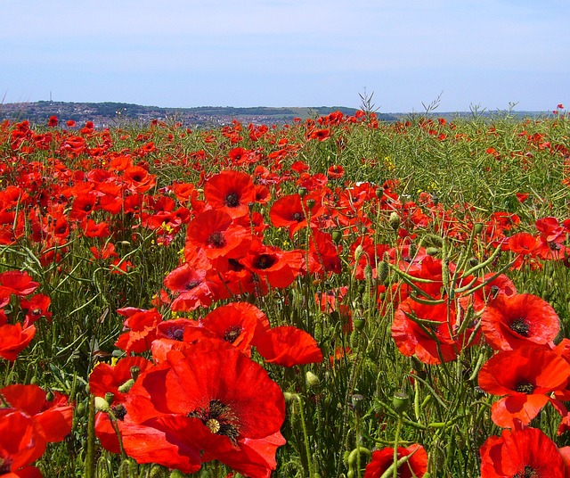

NO SCHOOL NOVEMBER 11 Remembrance Day.

R

**C.H.S.M.E.S. NEWS**

**NOVEMBER 1, 2021**

462-9683

**UPCOMING EVENT**

.

**NOVEMBER 16**

**MORNING ONLY**

**REMINDERS**

* **Be sure to send your child with snacks every day.**
* Please send your child with at least 2 clean masks every day and remember to keep them home if they have **ANY** symptoms.
* Due to the students spending extra time outside for gym, music, and language class we are asking that you please send them in the proper outdoor clothing. **(I.e., warm jackets, mittens, hats, etc.)**
* Don’t forget about Wolastoq Wednesdays; your child can wear their traditional clothing, regalia or CHSMES swag.

**NOVEMBER 8TH TO 12 th**

**NEXT WEEKS ’S**

**Hot Lunch Menu**

**Monday –** Tomato Soup And Crackers

**Tuesday –** Crisp Chicken Wraps

**Wednesday** – Cold Cut Combo Subs

**(Grade 6 & Afterschool ONLY)**

**Thursday** – No School Remembrance Day

**Friday** –Mini PIZZA’s

