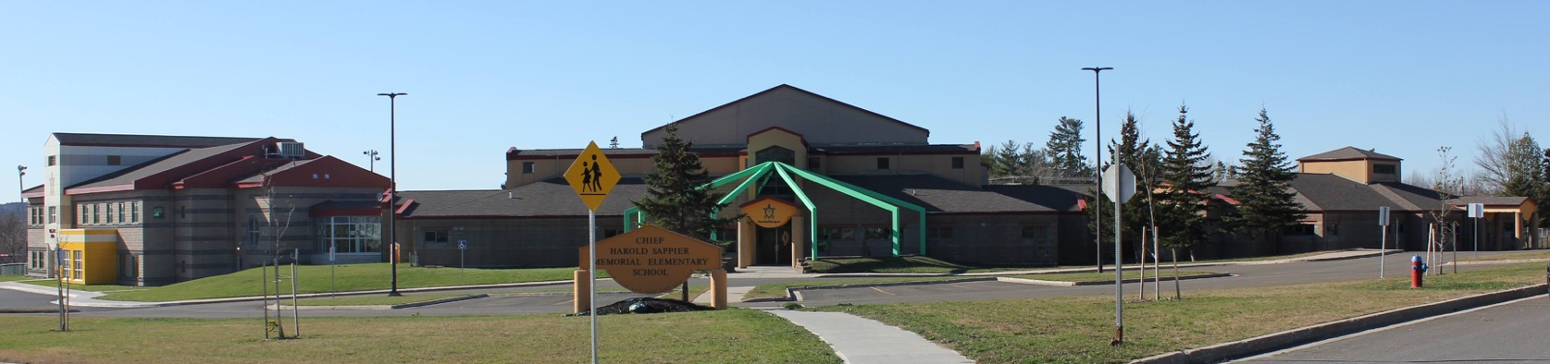

**C.H.S.M.E.S. NEWS**

**October 19, 2020**

462-9683

**SEPTEMBER 2008**

[](http://www.google.ca/imgres?q=halloween+parade&start=261&um=1&hl=en&safe=active&sa=X&rlz=1R2ACAW_enCA389&biw=1440&bih=604&tbs=itp:clipart&tbm=isch&tbnid=X6-Rp6hCsdzWlM:&imgrefurl=http://www.treasurecoast.com/index.cfm/halloween-happenings/city-of-vero-beach-53rd-annual-halloween-parade/&docid=JOoKqRm4KzgdwM&imgurl=http://www.treasurecoast.com/default/cache/file/FC3FB493-C418-98F0-831BED4EC749FD15_medium.jpg&w=180&h=180&ei=vjyFUK-sMIn20gHM_4DgCQ&zoom=1&iact=hc&vpx=583&vpy=262&dur=128&hovh=144&hovw=144&tx=74&ty=112&sig=112088929412492552106&page=10&tbnh=132&tbnw=132&ndsp=31&ved=1t:429,r:79,s:200,i:241)

Halloween Parade

October 29, 2020

Starting at 10:30 a.m.

This year our Halloween Parade will look a little different. We will leave our designated entrances (the doors your child enters and exits every day) during staggared times starting at 10:30 . We will parade down the sidewalk, continue on to the pipeline road in front of the school, then down Maliseet Dr and back to the school. We ask parents who are waiting outside have their mask on and keep your physical distance of 6ft.

**If it is raining the parade will be cancelled but students may still wear their costume ☺**

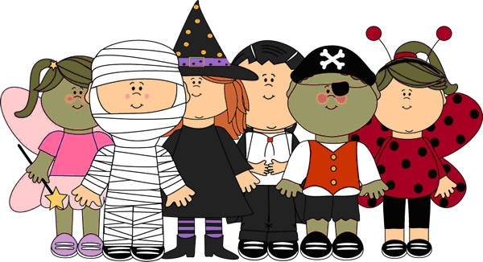

**NO SCHOOL ON FRIDAY, OCTOBER 30**

**PROFESSIONAL DEVELOPMENT DAY**

Please be advised there has been a change to the 2020-21 School Calendar. The Professional Development Day Scheduled in February has now changed to October 30, 2020. Please see the new school Calendar for the changes.

**REMINDER**



TUESDAY

OCTOBER 20, 2020

“Siktelom”

(Smile)



**THURSDAY**

**October 29, 2019**

**MONTHLY RECOGNITION VIRTUAL AWARD ASSEMBLY**

**1:00 P.M.**

**Covid-19 update**

All individuals who have traveled to the Moncton or Campbellton Regions since Friday, October 9, must wear a mask inside our

school and classroom, outside the school at noon/recess, and while on the bus for a period of 14 days from the day they returned to our region. Students are still expected to bring two (2) personal face masks with them to school daily. Remember we are all in this together ☺

|  |  |
| --- | --- |
| **CLOTHING ORDER FORM**  **ORDERS ARE DUE ON**  **Thursday, October 29, 2020**  **CASH ONLY**  **Colors will be available on school facebook and website www.chsmes.ca** | **HOT LUNCH**  **STARTING FRIDAY**  **OCTOBER 23**  **PLEASE RETURN ORDER FORM AND $$$** |

