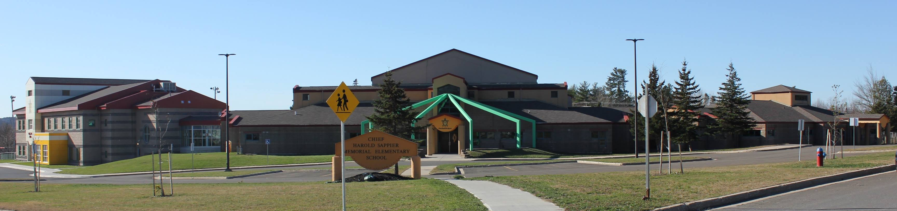
C.H.S.M.E.S. NEWS
October 5, 2020
462-9683
SEPTEMBER 2008

Toonie for Terry

Friday, October 23, 2020
Starting at 10:30 A.M.
Once again, CHSMES is hosting a Terry Fox Walk . All funds raised through our event will be forwarded to the Terry Fox Foundation to further the cause of cancer research. Due to Covid-19 restrictions, each class will walk in the gym this year. Thank you for your continued support towards a great cause!!

SCHOOL PHOTOS
TUESDAY, OCTOBER 20

NO SCHOOL
MONDAY, OCTOBER 12
THANKSGIVING DAY HOLIDAY

Parents/Guardians will be expected to provided their child with a personal face covering to wear at school ONLY when physical distancing is not possible and during Emergency situations such as fire drills. PLEASE REMEMBER TO CONTINUE TO SEND YOUR CHILD WITH THEIR MASK. Please help keep everyone safe! We are all in this together

