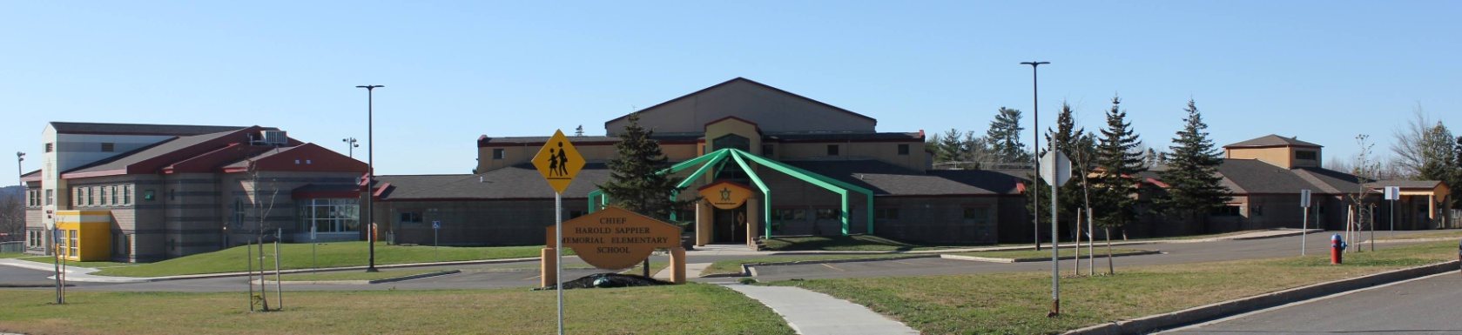

**C.H.S.M.E.S. NEWS**

**September 28, 2020**

462-9683

**SEPTEMBER 2008**

**Late Arrivals and Absences**

Please ensure that your child arrives at CHSMES early enough to be ready to start school on time. When your child will be absent or late, please call us at 462-9683 by 8:10 am each day. Attendance is taken daily in the morning, the secretary will contact the parents of any student unaccounted for.

If your child arrives after class has started, please follow this procedure:

* Parents, students and visitors are required to use the Main Office Entrance.
* Notify the Secretary or Principal on the arrival of your child.

**BICYCYLE SAFETY**

Please remind your child to be careful when biking to and from school. An area of concern is where the Pipeline Road/Bear Drive connects with Maliseet Drive. Parents please remember to drive slowly when in a school zone and remind all visitors to the area to do so as well.





SCHOOL PICTURE DAY

Tuesday, October 20

