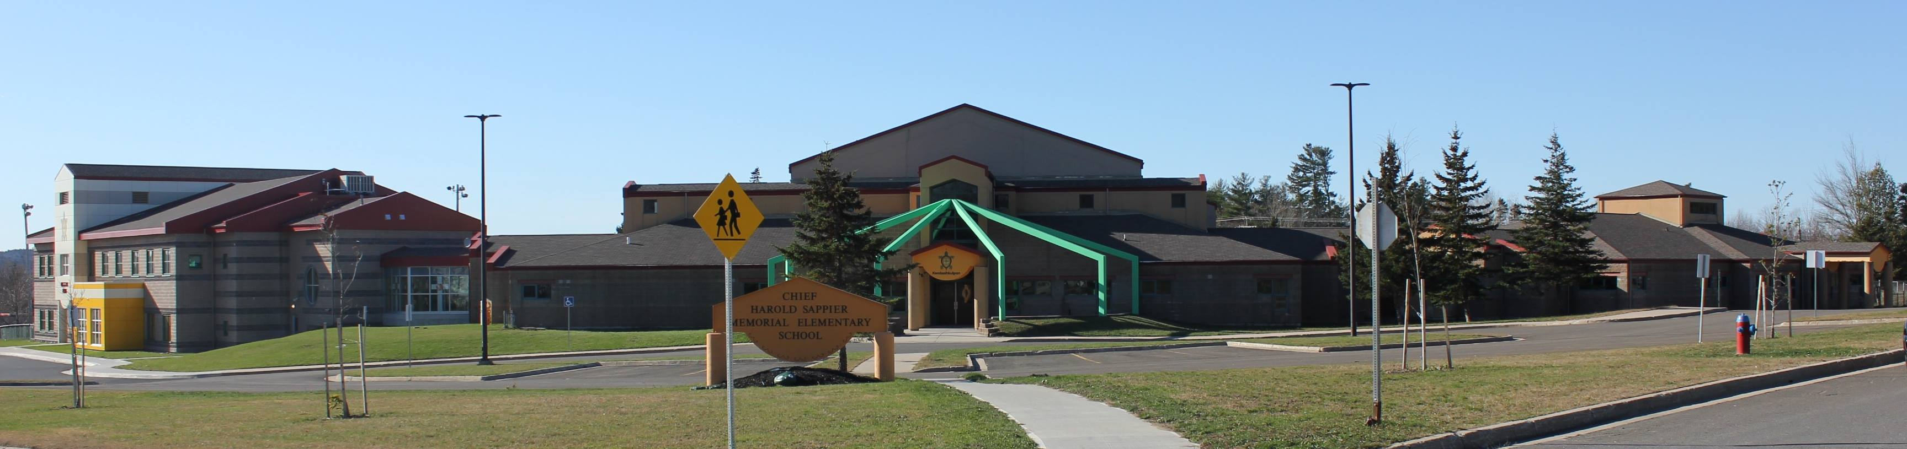

CHSMES

Student & Parent

Handbook

2021-2022

Chief Harold Sappier Memorial Elementary School
305 Maliseet Dr.
Fredericton, N.B. E3A 5R7
(506) 462-9683
WWW.CHSMES.CA

Dear Families,
Last school year 2020 -21 we faced many challenges during the Covid-19 pandemic. Our parents, students, teachers and staff worked tirelessly to ensure our academic quality and sense of community were preserved while managing to keep all our CHSMES families safe.
As we look forward to the start of the new school year this fall, CHSMES administration, teachers, and custodians are to committed to providing a clean, safe, and child-friendly environment. We are now in the Green Phase and able to lift some restrictions from the last school year.
This year there will be no more classroom bubbles. Restrictions on music classes, sports and extra-curricular activities have also been lifted. Breakfast and Hot Lunch Programs will return to normal and the school bus will transport students at full capacity.
While New Brunswick and our community benefits from having relatively high vaccination rates, COVID-19 isn’t going to disappear. Variants of the virus continue to emerge, and new research is available every day. Vaccines are still not approved for children under 12, for this reason we are still at risk of cases of COVID-19 in our school.
To help protect the health and safety of our students and school personnel, particularly vulnerable ones, some protective health layers will remain in place through the coming year.
- CHSMES will focus on:
  - Promoting healthy behaviors such as hand washing
  - Enhanced Cleaning and disinfecting
  - Continue to wear masks in common indoor areas where physical distancing cannot be maintained and may remove them once they arrive in the classroom.
  - All school personnel are to be vaccinated with two doses or wear a mask and undergo regular testing.
  - Visitors to the school will be limited. All visitors to the school who are permitted beyond the “visitor zone”, will be asked to declare if they have any COVID-19 symptoms and be required to wear a mask.
Please be sure to read our Handbook. If you have any questions about our policies, please feel free to contact the school. This pandemic is constantly evolving, all changes are guided by the Public Health Department.
We continue to ensure that our school remains a safe and healthy environment and are committed to the continued learning and growth of the children at CHSMES.

CHSMES MISSION STATEMENT
“We at CHSMES are dedicated to providing a safe positive learning environment that focuses on the Cultural, Social and Academic development of our children.”

SCHOOL PROFILE
Chief Harold Sappier Memorial Elementary School (CHSMES) was opened in September 1999 and is named after the longest reigning chief from the St. Mary’s Community. Chief Sappier served his community for nearly 20 years. The naming of the school in his honor exemplifies the respect and honor for his commitment towards improving educational opportunities for children in the community.

CHSMES goals for each child:
- Inspire a lifelong desire to learn
- Develop excitement for learning and a desire to explore new ideas and concepts
- Create an interest in caring for our environment and ourselves
- Achieve appropriate balance in knowledge of the body, mind and spirit
- Create an environment that fosters responsible citizens
- Form a support team with the parents

Developmental Years
From birth to age nine are the most significant developmental years in your child’s life. Learning from the activities set before them, children absorb everything in their environment. To help children realize their educational potential, CHSMES provides a sequence of developmental activities that builds a solid foundation for higher levels of learning well into the future.

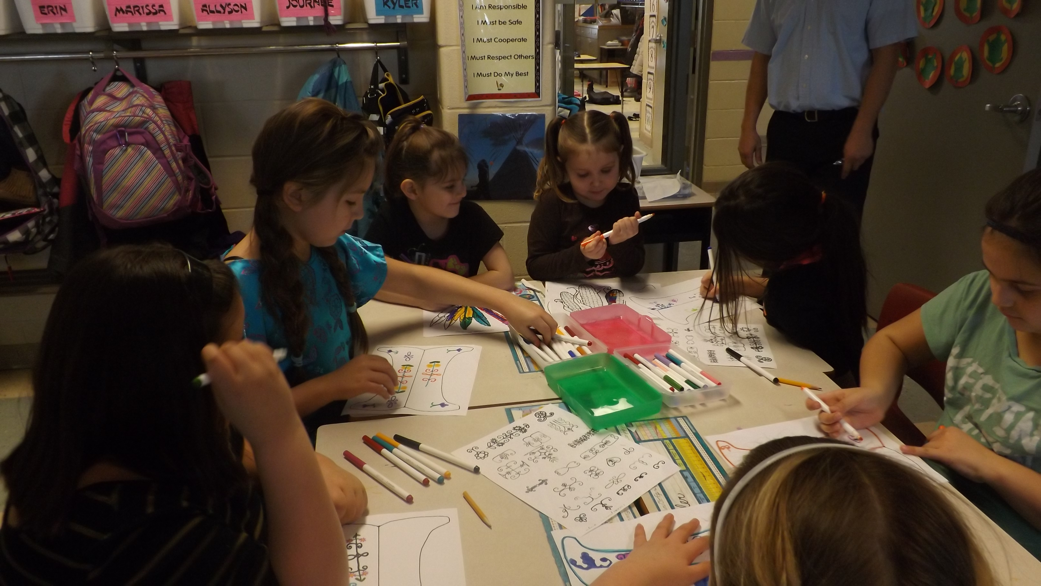

Basic Daily Schedules
KINDERGARTEN – GRADE 6
MONDAY, TUESDAY, THURSDAY & FRIDAY

Basic Daily Schedule
8:00 a.m. | Students enter classrooms
8:05 a.m. | Bus Arrives
8:10 a.m. | First Bell Rings
8:20 a.m. | Classes Begin
10:00 a.m. | Morning Snack
10:10 a.m. | Recess
10:25 a.m. | Recess Ends
12:00 p.m. | Lunch
12:45 p.m. | Classes Begin
2:00 p.m. | Kindergarten – Grade 2 Dismissal
2:00 p.m. | Afterschool Program Begins
2:45 p.m. | Grades 3 – 6 Dismissal
5:00 p.m. | Afterschool Ends

WEDNESDAY ONLY

K- 5 Dismissal at 12 Noon
Grade 6 Dismissal at 2:45 p.m.

ATTENDANCE & CONTACT TRACING
Please ensure that your child arrives at CHSMES early enough to be ready to start school on time. When your child will be absent or late, please call us at 462-9683 by 8:20 am each day. Attendance records will be maintained daily in order to track those who enter the building each day. This includes students, staff, parents and visitors.
(In the event of a positive case of COVID-19 among a student, staff member or visitor, CHSMES will immediately provide all contact tracing information to Public Health. Public Health will be responsible for all contact tracing measures and schools will take direction from Public Health.)
Attendance is taken daily in the morning; the secretary will contact the parents of any student unaccounted for.

If your child arrives after class has started, please follow this procedure:
- Parents, students and visitors are required to use the Main Office Entrance.
- Notify the Secretary or Principal on the arrival of your child.
- early departures, please contact the school to arrange for appointment pick-up.

Parents are responsible to notify the school of the reason for the absence from school.

VISITORS

All VISITORS will enter the building at the “Visitors Zone”, this is the main entrance by the Administration Office. (The entrance with the big green arms). Unless urgent or an emergency, all visitors to the school will be limited during the school hours of operation unless prearranged through the Principal or the School Manager. This includes drop-offs of late students, early pick-ups, forgotten lunches/item, etc. Please ensure your child brings their lunch, snacks, belongings, etc. required for the day at school. PLEASE LABEL ALL CHILD(REN’S) BELONGINGS. We will no longer hold any lost and found items. VISITORS WILL BE REQUIRED TO WEAR A MASK.

COMMUNICATION

We believe communication is key. We ask that you keep an updated number on file at all times as well as any other emergency contact phone numbers necessary. In case of an Emergency; If a parent/guardian cannot be reached, the emergency contacts will be called.

CHSMES offers many lines of communication to keep you updated on school events, classroom curriculum and your child’s progress. You will receive weekly newsletters that will include upcoming events and other items of interest to students and parents. The office staff and teachers will communicate with parents through e-mail and Facebook as well. You will be invited to join your child’s classroom page by their homeroom teacher. Individual classroom Facebook pages are used to keep you updated on what is happening in the classroom, and to keep you connected to the classroom teacher. Please note that any important messages such as bussing, or afterschool plan changes for your child, must come through the main office. To contact your child’s teacher, please call the school office. To contact a staff member by phone, please call the school office at 462-9683. Office staff will deliver the message, and your child’s teacher will return your call at the end of the school day. Your child’s teacher will also be available to meet with you to review your child’s progress report during our fall and spring parent/teacher conferences.

Student Illnesses
Parents/guardians will report any symptoms of COVID-19 to the school as soon as possible. Students who have two or more symptoms or who are feeling sick are to stay home and recommended to get tested. Students with one symptom will be required to wear a mask.

Symptoms of COVID-19 include:
- New or worsening cough
- Shortness of breath or difficulty breathing
- Fever
- Chills
- Sore throat
- Runny nose, sneezing, congestion
- Headache
- Muscle aches
- Purple Markings on Fingers and Toes

Each classroom will have a Thermometer in the event that temperature taking becomes necessary or in the event that a student becomes ill during the day. If a student has a fever (38 degrees or higher) they will be sent home and asked to self-monitor for 24hrs.

Parents/guardians will be expected to provide their child with a personal face covering (PPE) to wear at school if showing one symptom.

Students will remain home until they are free of symptoms.

If a STUDENT becomes ill with COVID-19 symptoms during the day:

- They will immediately put on a mask.
- Be taken to a supervised designated location.
- Family is contacted to pick up the child.
- Parents are to call 811 or their Health Care provider to arrange testing.

CHSMES will respect the confidentiality of any student who experiences COVID-19 symptoms and/or tests positive for COVID-19. Please follow the Public health advise if you are waiting for testing results for COVID-19 or have told to self-isolate.

If you have travelled outside regions as per the current Public Health Guidelines), you will need to declare this to the school and will be required to take the appropriate steps necessary before entering or returning to school. For the latest information visit www.gnb.ca/coronavirus

Scheduled School Closures
As a convenience to our families, CHSMES follows the Anglophone West School District’s calendar for holidays and school breaks, professional development days, parent/teacher conferences, etc. Please see the CHSMES calendar for all scheduled closures.
School Closures and Delays Due to Storms
CHSMES follows these procedures for closures and delays:
- When Anglophone West School District reports a district wide closure, CHSMES will close.
- When Anglophone West School District reports bus delays, CHSMES will:
  - Open at Usual Time.
  - Students arriving late before the bus arrives will not be marked as late arrival.
- If Anglophone West School District closes early, CHSMES will close early and notify parents via telephone, school website (www.chsmes.ca) Social Media (Facebook - CHSMES) and Radio. Please ensure your contact information is up to date.

Power Outages
For the safety of students and staff, CHSMES will close if the power is out for as long as 1-½ hours. CHSMES staff will call each family if this occurs. Students must be picked up within one hour of a phone call/message. Please keep your emergency contacts current with the office so that we can make special arrangements if you are unable to pick up your child.

Changes to Child’s Pick Up
To ensure your child’s safety, CHSMES requires a note from his/her parent if someone other than the parent is picking up your child.

Medication
In order for any medication (prescription, over-the-counter medicines and topical creams or ointments) to be administered at school, a parent must complete a Medication Authorization Form, available in the front office. All medication must be in the original container with the appropriate pharmacy label.
• Whenever possible, medication prescribed three times daily (antibiotics) should be given at home, e.g., at breakfast, after school and at bedtime.
• No medication of any kind (including over-the-counter products, such as antacids, lip gloss, or sunscreen) is to be applied or administered by a child, nor should any of these be placed in lunch boxes, backpacks or pockets.

Lunches and Snacks

- CHSMES promotes healthy lifestyles and have committed our school to a NO JUNK FOOD POLICY. Therefore NO pop, chips, chocolate bars, candy, fast food take-out will not be permitted during school hours.
- Please pack a well-balanced lunch for your child each day and do not include candy or other high sugar foods.
- Please send foods your child is familiar with and can successfully feed himself/herself.
- Students are provided with a 15 minute snack time each morning, should your child forget his/her snack we will be happy to provide one for him/her.

Peanut Policy
CHSMES is very attentive to students in our care who have severe nut allergies. We are aware that some can be life threatening. Teachers in each classroom and school staff are given a list of all children in the school who have allergies.
- No nuts, tree nuts or nuts products are allowed in any class snack.
- If you are providing snacks for your child's classroom, please send only commercially prepared, nut & tree nut free snacks.

What can parents do to help?
- Check all snacks that you provide to ensure they were not processed on machinery used for nut products.
• Help your child understand his/her special dietary needs and emphasize the importance of not sharing food with others.
- If your children are allergy free, help them understand the seriousness of allergies and the potential consequences of children with allergies by being exposed to allergens.

Field Trips
Field trips are a valuable part of CHSMES programs. Permission forms will be signed by parents for each field trip outside of the school. These forms will contain the trips purpose, itinerary, including date, time, method of transportation and any additional information. All children must have parent permission to go on a field trip. Students who don’t have permission will remain at school and are placed in another classroom. (Due to the pandemic, field trips will follow bus policy and only in Bubble groups)

Footwear

All students are required to have indoor shoes for indoor use (not necessarily brand new) preferably sneakers. Proper outdoor footwear should be appropriate to the season and daily weather conditions.

Emergency Drills
CHSMES conducts emergency drills throughout the year. Learning safe, orderly and controlled conduct is the primary purposes of emergency drills. Emptying the building quickly is certainly an important goal but is secondary to the maintenance of proper order and discipline. The first few drills of the year are announced in advance to allow students to learn to conduct themselves appropriately. All remaining drills are unexpected and are conducted at different times of the day to get students accustomed to conditions of a real emergency.

Behavior Guidelines
Our goal is to provide a learning environment that is safe, supportive and nurturing for every student. CHSMES has developed the “Nifty Fifty” Program which promotes appropriate behavior in the classroom. Clear expectations are taught to the students at the beginning of the school year and explained to parents during “Meet the Teacher Night”. Special activities are planned throughout the month for students who stay on “fifty”. Only those students are able to participate in those activities.

Disruptive Behavior Policy
When a child exhibits excessive disruptive behavior, the following procedures are followed:
1. After the first occurrence, we review with the child and/or parent the behavior we expect, and we send an incident report home to the parents.
2. When a child is excessively disruptive a second time, we immediately schedule a conference with the parents to again review the behavior we expect and/or to require the parent to pick up the child within one hour.
3. The third time the child engages in the prohibited behavior, we call the parents, and the child is required to leave school for the rest of the day.
4. After the fourth disruptive event, CHSMES asks the parents to initiate counseling for the child and family and to provide the school with a letter from the counselor verifying that the counseling process has begun. Once the counseling starts, the parents must immediately submit a behavior plan to the school.

*For the safety of all staff and students, if any child instigates dangerous behavior, we will go directly to step 4.

YEAR END AWARDS

- All students will receive a Grading Award
- Maliseet Award
- Female & Male Athlete of the Year

TRANSPORTATION
Students in all grade levels are required to wear masks on the bus
To mitigate the risks of COVID-19:
- Parents will be encouraged to drop off and pick up students.
- Strongly encourage walking, biking, and alternative means of transportation.
- Parents will ensure physical distancing when dropping off and picking up their child(ren).
- Students to wear at all times.
- No seating restrictions on bus, but students should try to sit in same seat when possible.

DESIGNATED BUS STOPS

Please Note: Students will be dropped off at their designated bus stop. Please ensure your child knows where he/she is going at the end of the day.

Morning Bus Schedule: K5-Grade 6: Bus # 3 driven by Katie Paul 7:50am
Designated Bus Stops: (Top of Community)
Stop 1: 190 Bear Drive
Stop 2: 125 Bear Drive
Stop 3: 50 Gabe Acquin Drive
Stop 4: 100 Gabe Acquin Drive
Stop 5: Corner of Saulis Court & Gabe Acquin Drive
Stop 6: Corner of Meuse Court & Gabe Acquin
Stop 7: Top of Gabe Acquin
Stop 7: Corner of Barlow Court & Gabriel Drive
Stop 8: Corner of Sacobie Court & Gabriel Drive

Morning Bus Schedule: K5-Grade 6: Bus # 2 driven by Steve Meuse 7:50am
Designated Bus Stops: (Bottom of Community)
Stop 1: 237 Maliseet Drive
Stop 2: 217 Maliseet Drive
Stop 3: 180 Maliseet Drive
Stop 4: 157 Maliseet Drive
Stop 5: 97 Maliseet Drive
Stop 6: 117 Paul Street
Stop 7: 197 Paul Street
Stop 8: 430 Maliseet Drive
Stop 9: 505 Maliseet Drive
Stop 10: 505 Maliseet Drive
Stop 11: Corner of Polches Court & Maliseet Drive
Stop 12: Corner of Brooks Court & Maliseet Drive
Stop 13: Corner of Maliseet Drive & Bear Lane
Afternoon Bus Schedule: (Monday-Tuesday-Thursday-Friday)
2:00pm- Katie Paul will pick up K5- Grade 2
2:45pm- Katie will pick up Grades 3-6

WEDNESDAYS Schedule
12:00pm- Pick up CHSMES students K5 – Grade 5.
2:45 pickup for Grade 6

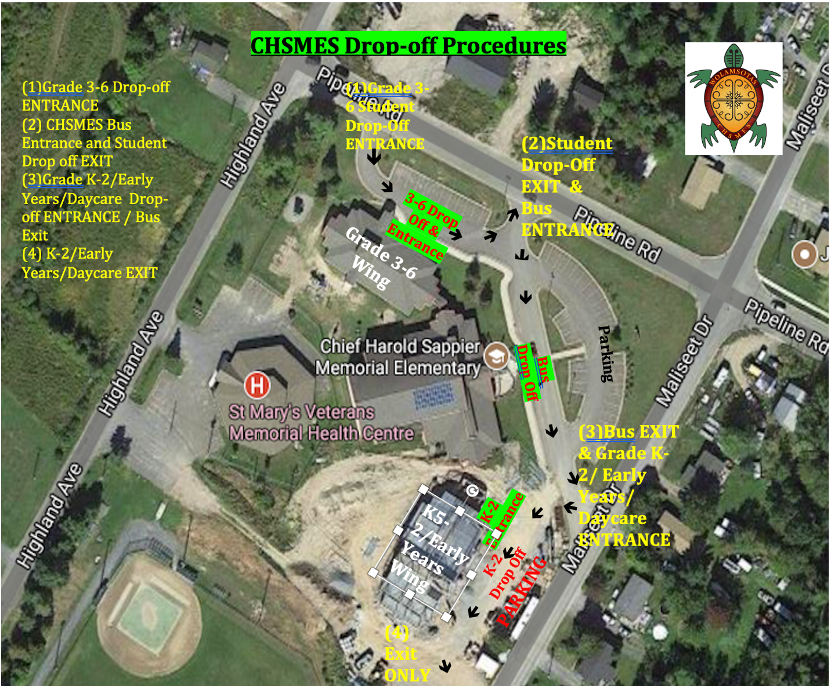

CHSMES SCHOOL STAFF

Principal: Mr. Mathew Seymour
Elder In Residence: Opolosomuhuwas – Imelda Perley
School Manager: Judith Fullarton
Reception assistant: Destiny Wood & Jennifer Polchies
Custodians: Mr. Brian Duthie, Mr. Nick Paul, Mr. Troy Paul, Mr. Nelson Barlow

Kindergarten
Teacher: Mrs. Catherine Saunders
Teacher: Ms. Dana Brooks
Grade One
Teacher: Ms. Karlee Muise
Teacher: Ms. Ashley Frawley
Grade Two
Teacher: Ms. Jenny Paul
Grade Three
Teacher: Mrs. Marianna Mills
Grade Four
Teacher: Mr. Andrew Fisher
Grade Five
Teacher: Ms. Melissa Boyer
Grade Six
Teacher: Mrs. Kristy Francis

Physical Education Specialist: Mr. Stephen White
Maliseet Language Teacher: Mrs. Jessica Thibodeau
Music Specialist: Mr. Jeff Zaat
Guidance Counsellor: Mr. Jason Morrison
Methods & Resource Specialist: Patricia Gallant
Literacy Specialist: Mrs. Kaitlyn Hicks
Numeracy Specialist: Mrs. Hilary Murray
Speech Pathologist: Mrs. Merrilee Lawrence
Occupational Therapist: Mrs. Chelsie Beckett
Occupational Therapist Assist: Mrs. Miranda Traer
Behaviour Specialist : Mrs. Laurie Buyting
Behaviour Specialist: Ms. Jennifer Bradley
School Nurse: Allie Barton
Teacher Assistant: Ms. Angela Paul
Teacher Assistant: Ms. Claudine Paul
Teacher Assistant: Mrs. Sonia Milliea
Teacher Assistant: Ms. Stephanie Prince
Teacher Assistant: Richelle Paul
Teacher Assistant: Samuel Brooks
Teacher Assistant: Melissa Knockwood
Teacher Assistant: Kailey Paul

